Program 1: WAP in Java to print the Fibonacci series
package Assignments;

public class FibonacciSeries {

public static void main(String[] args) {

int n1=0,n2=1,n3;

int range=6;

System.out.print(n1+" "); //0
System.out.print(n2+" "); //1

for (int i=0;i<range;i++) //i=0<6,i=1<6,i=2<6,i=3<6,i=4<6,i=5<6,(i=6<6 - Condition false)
{
n3=n1+n2; //n3=0+1=1,n3=1+1=2,n3=1+2=3,n3=2+3=5,n3=3+5=8,n3=5+8=13
System.out.print(n3+" "); //1,2,3,5,8,13
n1=n2; //n1=1,n1=1,n1=2,n1=3,n1=5,n1=8
n2=n3; //n2=1,n2=2,n2=3,n2=5,n2=8,n2=13
}
}

}

Output:
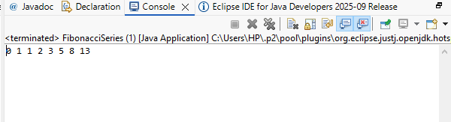

Program 2: WAP in Java to check if a number is prime or not
package Assignments;

import java.util.Scanner;

public class PrimeNumber {

public static void main(String[] args) {

int num, count=0;

System.out.println("Enter a Number: ");

Scanner sc=new Scanner(System.in);
num=sc.nextInt();

for(int i=1;i<=num;i++)//1<=3,2<=3,3<=3,4<=3-Condition false
{
if(num%i==0) //3%1=0,3%2=1-Condition false,3%3=0
{
count++; //1,2
}
}

if(count==2)
{
System.out.println("Number is Prime");
} else {
System.out.println("Number is not Prime");
}
}
}

Output:
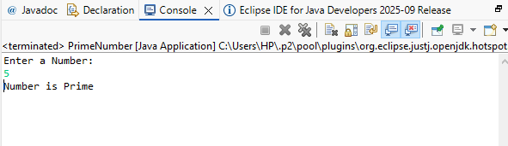
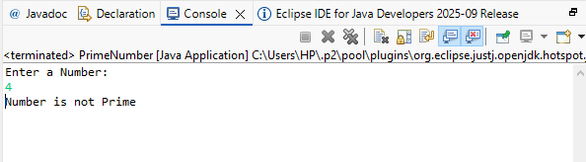

Program 3: WAP in Java to find the factorial of a number

package Assignments;

import java.util.Scanner;

public class Factorial {

public static void main(String[] args) {

int num, fact=1;

System.out.println("Enter a Number: ");

Scanner sc=new Scanner(System.in);
num=sc.nextInt();

//Ascending order
// for(int i=1;i<=num;i++)
// {
// fact=fact*i;
// }
//
// System.out.println("Factorial of a given number is: "+fact);

//Descending order
for(int i=num;i>=1;i--) //i=5>=1,i=4>=1,i=3>=1,i=2>=1,i=1>=1
{
fact=fact*i; //1*5=5,5*4=20,20*3=60,60*2=120,120*1=120
}

System.out.println("Factorial of a given number is: "+fact);
}

}

Output:
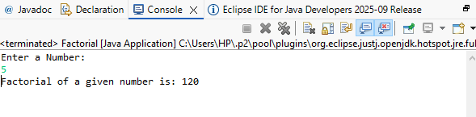

Program 4: WAP in Java to check if a number is Armstrong or not

package Assignments;

import java.util.Scanner;

public class ArmStrong {

public static void main(String[] args) {

int num;

Scanner sc=new Scanner(System.in);
System.out.println("Enter a number: ");
num=sc.nextInt();

int sum = 0;
int armNum = num;
int countDigit = num;
int count = 0;

while (countDigit != 0) { //counting the number of digits
countDigit = countDigit/10;
count++;
}
while (armNum != 0) { // logic for Armstrong
int digit = armNum % 10;
sum = sum + (int) Math.pow(digit, count);
armNum = armNum / 10;
}

if(num==sum) {
System.out.println("Number is a Armstrong Number");
}else {
System.out.println("Number is not a Armstrong Number");
}
}

}

Output:
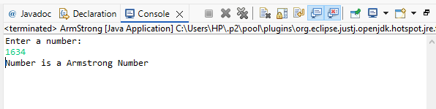
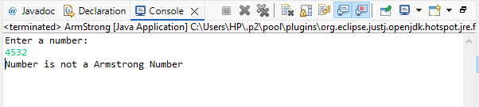

Program 5: WAP in Java to find reverse of number and check whether palindrome or not
package Assignments;

import java.util.Scanner;

public class ReverseOfNumberAndPalindrome {

public static void main(String[] args) {

Scanner sc = new Scanner(System.in);
System.out.println("Enter a number: ");
int num = sc.nextInt();

int originalNum=num, rev=0;

while(num!=0)
{
int digit = num%10;
rev=rev*10+digit;
num=num/10;
}

System.out.println("Reverse of number is "+rev);

if(originalNum==rev)
{
System.out.println("It is a Palindrome");
}
else
{
System.out.println("It is not a Palindrome");
}

}

}

Output:
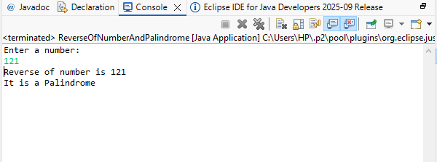

Program 6: WAP in Java to find largest between five numbers
package Assignments;

import java.util.Scanner;

public class LargestBetweenFiveNumbers {

public static void main(String[] args) {

Scanner sc = new Scanner(System.in);

System.out.println("Enter first number: ");
int a = sc.nextInt();

System.out.println("Enter second number: ");
int b = sc.nextInt();

System.out.println("Enter third number: ");
int c = sc.nextInt();

System.out.println("Enter fourth number: ");
int d = sc.nextInt();

System.out.println("Enter fifth number: ");
int e = sc.nextInt();

if (a >= b && a >= c && a >= d && a >= e) {
System.out.println("a is max");
}
else if (b >= a && b >= c && b >= d && b >= e) {
System.out.println("b is max");
}
else if (c >= a && c >= b && c >= d && c >= e) {
System.out.println("c is max");
}
else if (d >= a && d >= b && d >= c && d >= e) {
System.out.println("d is max");
}
else {
System.out.println("e is max");
}

}

}

Output:
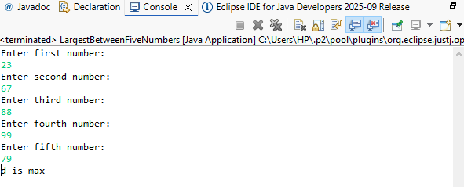

Program 7: WAP in Java to find the sum of all even numbers from 1 to 20
package Assignments;

public class SumOfEvenNumbers {

public static void main(String[] args) {

int i = 1;
int sum = 0;

do {
if (i % 2 == 0)
{
sum = sum + i;
}

i++;

}

while (i <= 20);

System.out.println("The sum of all even numbers from 1 to 20 is: " + sum);

}

}

Output:
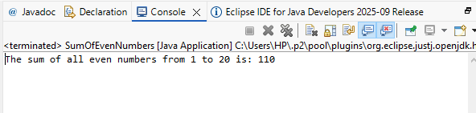

Program 8: WAP in Java to find the Amount and SI for P=50000, t=6 years, r=4%
package Assignments;

import java.util.Scanner;

public class AmountAndSI {

public static void main(String[] args) {

Scanner sc = new Scanner(System.in);

System.out.println("Enter Principal amount P: ");
double P = sc.nextDouble();

System.out.print("Enter Rate of interest R: ");
double R = sc.nextDouble();

System.out.print("Enter Time in years T: ");
double T = sc.nextDouble();

double SI = (P * R * T) / 100; // Simple Interest formula

double Amount = P + SI; // Amount formula

System.out.println("Simple Interest SI: " + SI);
System.out.println("Total Amount A: " + Amount);

sc.close();

}

}

Output:
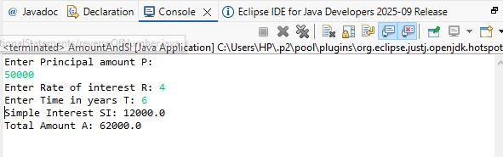

Program 9: WAP in Java to find GCD of two numbers
package Assignments;

import java.util.Scanner;

public class GCDOfTwoNumbers {

public static void main(String[] args) {

Scanner sc = new Scanner(System.in);
System.out.println("Enter any two numbers: ");
int a=sc.nextInt();
int b=sc.nextInt();

int greatestCommonDivisor=0;

for(int i=1;i<=a;i++)
{
if(a%i==0 && b%i==0) //finding common factors
{
greatestCommonDivisor=i;
}
}

System.out.println("GCD of two numbers: " + greatestCommonDivisor);

}

}

Output:
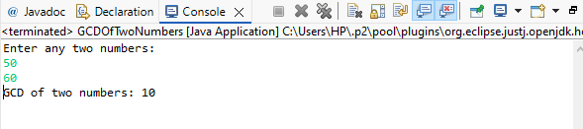

Program 10: WAP in Java to find the sum of all odd number from 12 to 20
package Assignments;

import java.util.Scanner;

public class SumOfOddNumbers {

public static void main(String[] args) {

Scanner sc = new Scanner(System.in);

System.out.print("Enter the starting number: ");
int start = sc.nextInt();

System.out.print("Enter the ending number: ");
int end = sc.nextInt();

int sum = 0;
int i = start;

System.out.println("Odd numbers in the given range are: ");

do {
if (i % 2 != 0) //checking if the number is odd
{
System.out.print(i + " ");
sum = sum + i;
}

i++;
}

while (i <= end);

System.out.println("\nSum of all odd numbers from " + start + " to " + end + " is: " + sum);

sc.close();

}

}

Output:
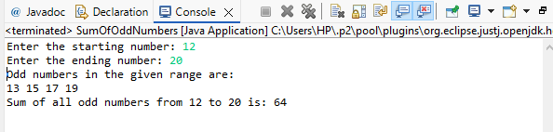

Program 11: WAP in Java to print the Diamond pattern
package Assignments;

import java.util.Scanner;

public class DiamondPattern {

public static void main(String[] args) {

Scanner sc = new Scanner(System.in);
System.out.print("Enter number of rows for the diamond: ");
int row = sc.nextInt();

for(int i=0;i<row;i++)
{
for(int j=0;j<row-i-1;j++) //Printing spaces
{
System.out.print(" ");
}

for(int j=0;j<=i;j++) //Printing stars
{
System.out.print("* ");
}

System.out.println();
}

for(int i=0;i<row-1;i++)
{
for(int j=0;j<=i;j++) //Printing spaces
{
System.out.print(" ");
}
for(int j=0;j<row-i-1;j++) //Printing stars
{
System.out.print("* ");
}

System.out.println();
}

}

}

Output:
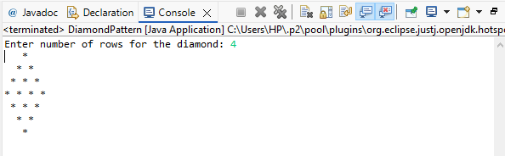
Program 12: WAP in Java to print the Number Increasing Pyramid

package Assignments;

import java.util.Scanner;

public class NumberIncreasingPyramid {

public static void main(String[] args) {

Scanner sc = new Scanner(System.in);
System.out.print("Enter number of rows for the Number increasing pyramid: ");
int row = sc.nextInt();

for(int i=1;i<=row;i++)
{
for(int j=1;j<=i;j++)
{
System.out.print(j+ " ");
}

System.out.println(" ");
}

}

}

Output:
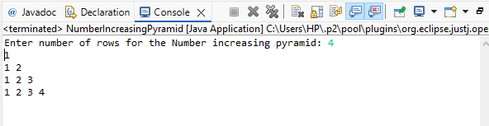

Program 13: WAP in Java
Create a Class named Shape with length as instance variable , create three methods as square , rectangle , circle and find out their respective areas .
Create a object in main method and call these different methods with the instance of object

package Assignments;

class Shape
{
double length;

Shape(double length) {
this.length = length;
}

void square()
{
double area = length * length;
System.out.println("Area of Square is: " + area);
}

void rectangle(double width)
{
double area = length * width;
System.out.println("Area of Rectangle is: " + area);
}

void circle()
{
double area = 3.14 * length * length; //Using length as radius
System.out.println("Area of Circle is: " + area);
}
}

public class AreasClassesAndMethods {

public static void main(String[] args) {

Shape sp= new Shape(4);
sp.square();
sp.rectangle(5);
sp.circle();

}

}

Output:
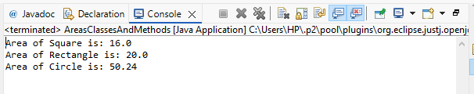

Program 14: WAP in Java
Create a class named school ,create name as their instance variables
Create a default constructor of this class which will have a print statement to display the name of school
Create a method inside the class which will display a message as "This School is based out of Kolkata"
Create a object under main method and call the constructor and the method

package Assignments;

class School
{
String name;

School()
{
name = "Gulab Glory Senior Secondary School";
System.out.println("School Name: " + name);
}

void displayMessage()
{
System.out.println("This School is based out of Kolkata");
}
}

public class MethodClassAndConstructor {

public static void main(String[] args) {

School sc = new School(); // calls the default constructor
sc.displayMessage(); // calls the method

}
}

Output:
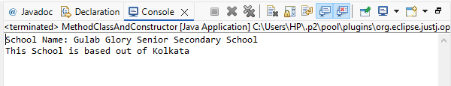

Program 15: WAP in Java
create a class named school
create name, address,strength as their instance variables
Create two constructor one with two variables and one with all the three variables
Create a method that will display all the three parameters
create two object of this class and call the respective methods

package Assignments;

class Schooll
{
String name;
String address;
int strength;

Schooll(String name, String address)
{
this.name=name;
this.address=address;
}

Schooll(String name, String address, int strength)
{
this.name=name;
this.address=address;
this.strength=strength;
}

void display()
{
System.out.println("School Name: " + name);
System.out.println("School Address: " + address);
System.out.println("School Strength: " + strength);
}
}

public class MethodClassAndConstructorQue2 {

public static void main(String[] args) {
Schooll sc1 = new Schooll("Gulab Glory School", "Udaipur");
sc1.display();

Schooll sc2 = new Schooll("Gulab Glory School", "Udaipur", 5000);
sc2.display();

}

}

Output:
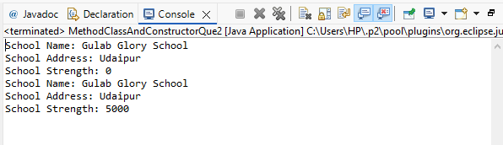

Program 16: WAP in Java
Write a constructor in the Car class given below that initializes the brand class field with the string â€œFordâ€.
Call the getBrand() method in the main method of the Sample class and store the value of the brand in a variable, and print the value.

package Assignments;

class Car
{
String brand;

Car()
{
brand="â€œFordâ€.";
}

String getBrand()
{
return brand;
}
}

public class CarClassAndMethods {

public static void main(String[] args) {

Car c = new Car();
String brandOfCar = c.getBrand();
System.out.println("Brand of the car: " + brandOfCar);

}

}

Output:
